EX NO 10 : Counting Uppercase and Lowercase Characters Using LEX

Aim:
To write a LEX program to read a text file and count the number of uppercase and lowercase alphabetic characters.
Algorithm:
- Start the program.
- Initialize uppercase and lowercase counters to zero.
- Read the text file character by character.
- Increment the uppercase counter for letters A–Z.
- Increment the lowercase counter for letters a–z.
- Display both counts.
- Stop the program.
Program:
%{
#include <stdio.h>
int upper = 0, lower = 0;
%}

%%
[A-Z] { upper++; }
[a-z] { lower++; }
.|\n ;
%%

int main()
{
yylex();
printf("Uppercase characters = %d\n", upper);
printf("Lowercase characters = %d\n", lower);
return 0;
}

int yywrap()
{
return 1;
}Sample input:
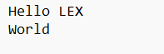
Sample output:
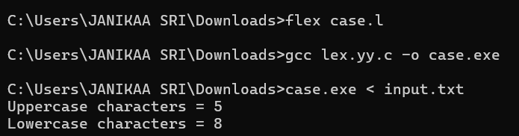

Result:
The LEX program was executed successfully to count and display the number of uppercase and lowercase alphabetic characters in the given text file.

